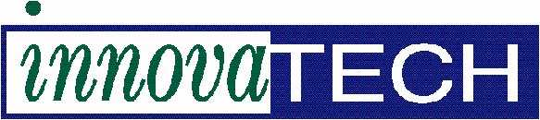
Innovatech Labs, LLC
13805 1st Ave. N, Ste 100
Plymouth, MN 55441
Sample Testing Form

Company Name:
Person Submitting:
Company Address:
City, State, Zip:
Phone Number:
Email Address:
Additional Email Address(es)
You would like the report sent to:

Sample Identification:

Quote #: (If applicable):
Objective: (Please be Specific)

Hard Copy of the Report: Yes ☐ No ☐

Sample Return Requested: Yes ☐ No ☐
If YES, please provide shipping account number: UPS: ☐ FedEx: ☐ /Acct Number:

Date Needed By: Standard Turn-around (5 business days): ☐
3-4-day guarantee (50% Expedite Fee): ☐ *
2-day turnaround (100% Expedite Fee): ☐ *
*MUST INITIAL HERE TO OK RUSH CHARGES:

We accept Payment with a PO or Credit Card. If using a PO, it MUST be included when submitting samples.
PO Number:

Credit Card Information: If you prefer to call in your information, please call 763-231-0150.
VISA ☐ Mastercard ☐ AMEX ☐
Name listed on card:
Card Number:
Expiration Date:
Security Code:
Form 100-1

